Upper Miramichi Elementary School
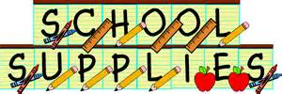

Grade 1, 3, 4 2022/23
- $50 student fee
- Reusable water bottle
- Box of plastic spoons
- 2 boxes of Kleenex
- 2 boxes of large Ziploc bags
- Backpack
- Lunchbox
- Indoor shoes

NOTE:

- If possible, it is a good idea to have supplies at home such as pencil, erasers, notebook, and crayons.

- First day of school- Tuesday, September 6, 2022.

